Functioneel Ontwerp

 Fontys Hoge School

RB05-4

Requirements 3

Functional 3

Non-Functional 3

Sitemap 4

UI Designs 5

Forms 7

# Requirements

## Functional

* Authentication (login/register)
* The user is able to create an account when providing the required data.
* Authorisation (User roles)
* Upload strategies
* Automatically run multiple strategy tests with different parameter entries
* Generate advice based on test results
* Do not test strategies with duplicate parameter entries

## Non-Functional

* Project meets GDPR standards
* Performance (A single test should finish within 2 minutes)
* Scalability (software can serve X amount of users per second)
* Reliable (X amount of uptime)
* Robust (no crashes/errors should be handled)
* Transferable code (documentation)
* User-Friendly UI

# Sitemap

In the User Interface you can navigate to the **Login Page** to login/register, **Testing Strategy** page for executing tests and adding new tests, **Testing Status** to see the status of the running tests and **Testing Results** to see the finished tests with advice given.

# UI Designs

Below are the UI mockups / designs made for the application we are planning to build. These are subject to change during the researching process.

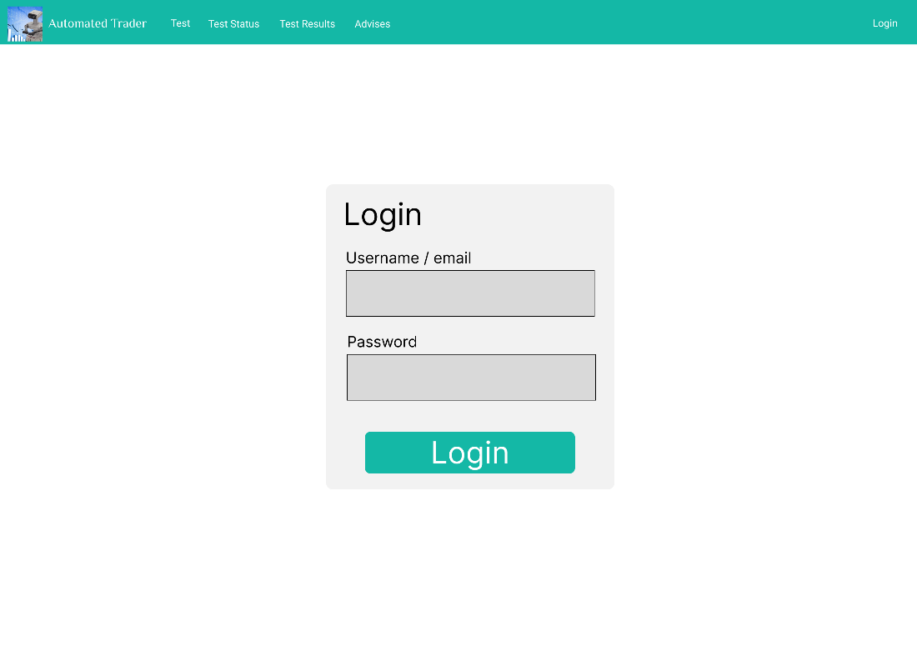

This is a basic log in screen. The function of this screen is to let users log in. Every user should have their own account because the application may be launched in the future. An account system could enable the application owner to charge users for trading strategy testing. During the development of the project, it ensures that only developers and stakeholders get access to the application if it were to be deployed.

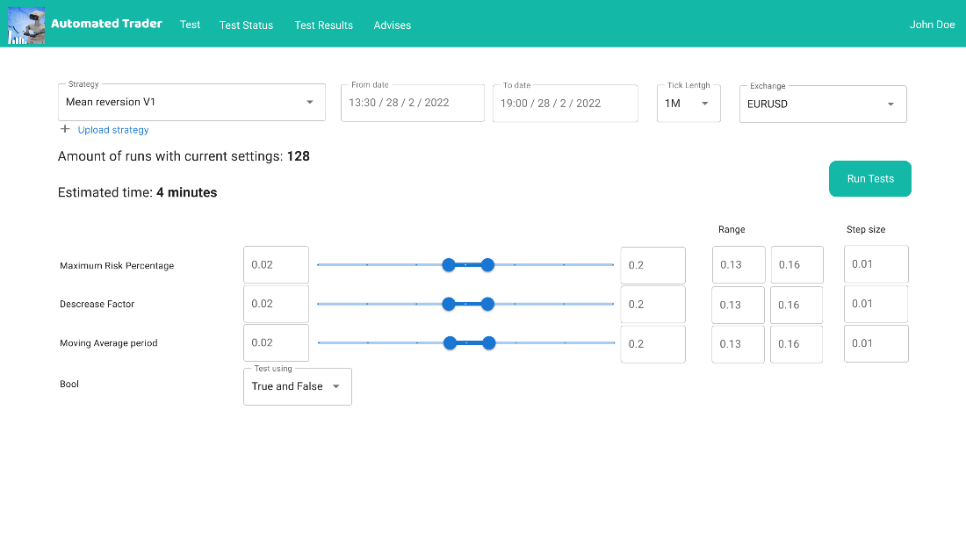

This screen will allow the user to set up the tests they want to run. In the top left, the user chooses a strategy. These strategies can also be uploaded here. The user will be able to set the time frame during which the tests are ran, the tick length and which exchange to run the strategy for.

When a strategy is chosen, all its variables are shown on the screen. The user can set a testing range for each variable by either changing the sliders or the range input fields. The user can also set a step size for this range. In this example, the variable “Maximum Risk Percentage” will be tested for the values 0.13, 0.14, 0.15 and 0.16.

After setting ranges and step sizes, the application will calculate how many unique variable value combinations there are. In this case there are 4x4x4x2 = 128 different combinations. This means that 128 tests will be performed during the chosen timeframe with the chosen tick length and exchange.

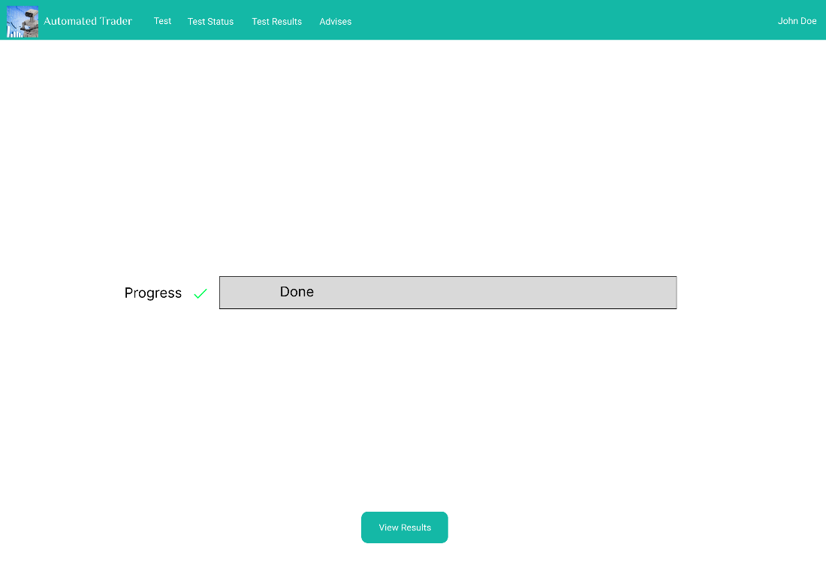

This screen shows a progress bar of the tests being completed

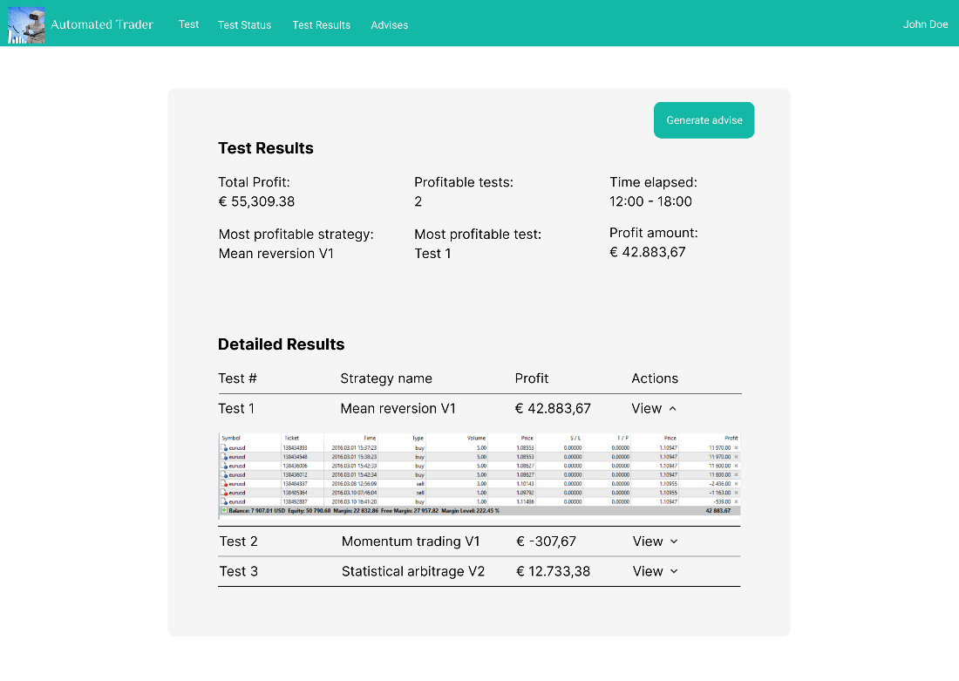

After all tests are done, the user is redirected to a result screen. Here the user can see how each test performed.

## Forms

Add strategy form Trader can upload strategy(s) by dragging file(s) or by clicking the browse files button.

